Junior Project
(PROGRESS REPORT#1)
Development of a Web-Based Course Allocation System for Faculty Members

Amna Al Shamsi U2114536
Asma Alali U22100601
Mahra AlKuhoori U22105880
Dana AlSafadi. U22200606

Project proposal for CS Junior Project
Computer Science
Supervisor:
Dr. Isam Al Jawarneh

College of Computing and Informatics
University of Sharjah

Introduction
The Web-Based Course Allocation System for Faculty Members focuses on simplifying and automating the process of distributing courses among university faculty. The project aims to reduce the amount of manual work that the Head of Department (HoD) usually has to do in order to improve efficiency, fairness, and transparency in course assignments.
The system primarily serves two user roles: The Head of Department (HoD), who will examine system-generated recommendations and authorize final allocations, and the Faculty Members, who will input their teaching preferences and academic specializations. Through a web interface, the system contains an algorithm that matches uploaded CVs to course requirements by extracting relevant information backed by ChatGPT based AI analysis.
This progress report documents the work completed up to the requirements gathering and functional modeling phases. It emphasizes the team's accomplished milestones and upcoming development processes, provides initial use case and activity models, and describes the system's essential needs.

2. Requirements Determination

2.1Functional Requirements
1. Faculty Management
1.1 Faculty can register and manage their profiles.
1.2 Faculty can specify teaching preferences and areas of expertise.
1.3 Faculty can view allocated courses after HoD approval.
2. Course Management
2.1 HoD can add, edit, and remove offered courses for each semester.
2.2 HoD can view course descriptions and requirements.
2.3 System recommends faculty-course matches based on expertise and preferences.
3. Allocation Management
3.1 System generates suggested course allocations.
3.2 HoD reviews and approves allocations.
3.3 Allocated courses are displayed in faculty dashboards.
4. User Dashboards
4.1 HoD Dashboard: Manage courses, view faculty details, and approve allocations.
4.2 Faculty Dashboard: View courses, update preferences, and view assigned courses.
5. Administrative Functions
5.1 Admin manages system users and permissions.
5.2 Admin oversees database backups and security settings.

2.2 Non-Functional Requirements

1.Usability
1.1 The interface should be user-friendly and accessible on multiple devices.
1.2 The design should be responsive and intuitive.
2. Scalability
2.1 The system should support additional faculties and courses in the future.
2.2 It should handle multiple concurrent users efficiently.
3. Security
3.1 Secure authentication and role-based access control.
3.2 Data encryption for sensitive information.

4. Reliability
4.1 Regular data backups.
4.2 High uptime and fault tolerance.

3. Business Process and Functional Modeling
3.1Use Case Diagram
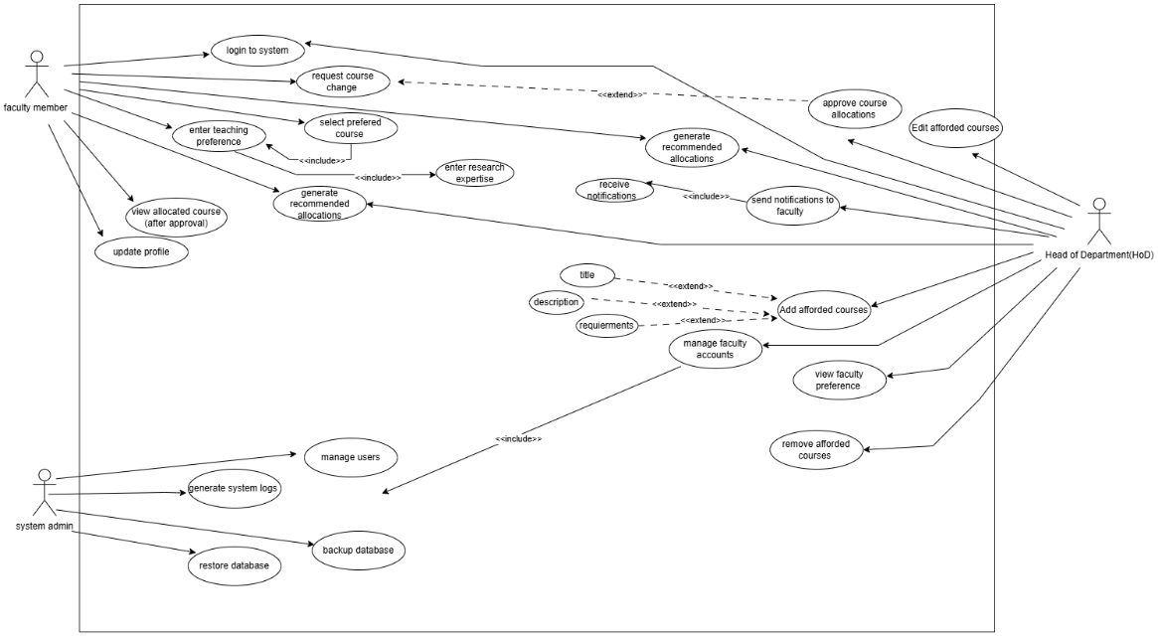
The Head of Department (HoD), faculty members, and the system administrator are the three primary actors that make up the Web-Based Course Allocation System, as shown in this use case diagram. Faculty members can choose their desired courses, add research specialties and teaching preferences, update their profiles, log in, and check the courses they have been assigned after approval. Managing course offerings, tracking faculty preferences, creating suggested allocations, approving final course assignments, and notifying faculty are all under the purview of the HoD. The system administrator is in charge of managing users, backing up and restoring databases, and doing system maintenance duties such creating logs. All things considered, the figure illustrates how each player works with the system to provide a well-organized, effective, and transparent distribution of courses.
3.2 Activity Diagrams

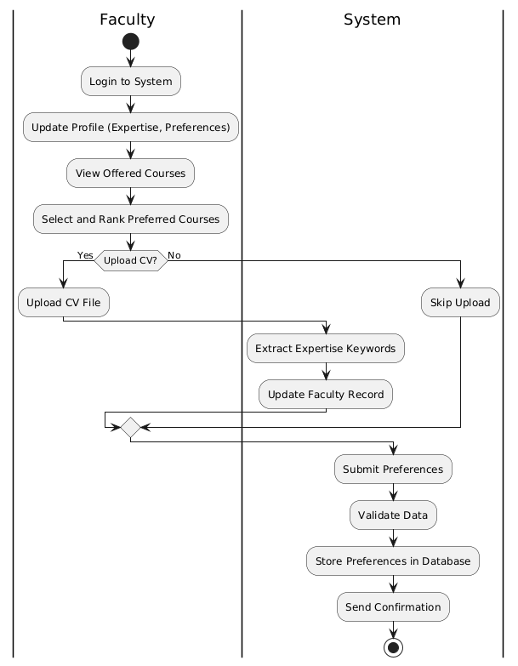
3.2.1Faculty Workflow
This activity diagram illustrates the steps instructors use to enter their preferred courses into the system. Updates to your profile and login are the first steps, after which you can view and choose your favourite courses. The system extracts information about expertise from a CV that faculty members can choose to upload. Following preference submission, the system verifies and saves the information before sending a confirmation message to guarantee a precise and easy submission process.

3.2.2 Activity Diagram – HoD Workflow

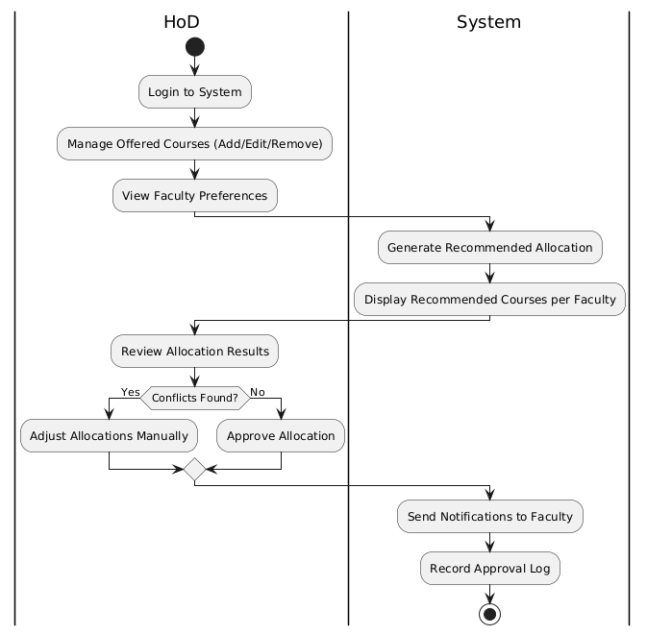
This figure illustrates how the system and the Head of Department (HoD) collaborate to assign courses. The HoD accesses the system, controls the courses that are provided, and looks at faculty preferences. After that, the system creates and shows suggested allocations. The HoD examines these findings, settles any disputes as necessary, and authorizes the ultimate distribution. Lastly, the system keeps track of the approval log and notifies the professors.

3.2.3 Activity Diagram – System Admin Workflow
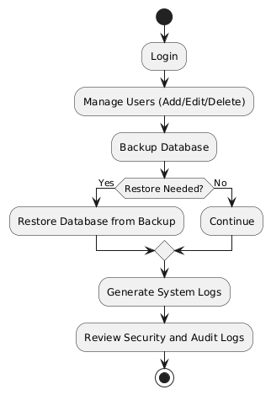
The user management and database security procedures are depicted in this diagram. The user logs in first, then manages people by adding, modifying, or removing accounts. A database backup is then carried out by the system. The database is restored from the backup if a restore is required; if not, the procedure is carried out. To guarantee appropriate system management and data integrity, the system then creates system logs, which are subsequently examined for security and audit issues.

4.summary
4.1Milestones Achieved
During this reporting phase, the team concentrated on the requirement determination and functional modelling stages, laying the groundwork for the system’s design and implementation in later phases. Here are a few significant milestones achieved:
Requirements & Research
• Carried out background study & research on the common problems universities encounter and the current course allocation mechanisms.
• Collected and improved the functional and non-functional requirements with a focus on security, scalability, and usability in accordance with the system goals.
• To direct the following stage, user roles (Faculty, HoD, and Admin) were explicitly defined, and their duties were documented.
Functional and Behavioural Modelling
• Use case diagrams were created to illustrate user interactions such choosing a course, approving an allocation, and maintaining the system.
• Activity Diagrams were created to help administrators, HoD, and faculty members understand how data and decisions flow through the system.
Structural Modelling and Conceptual Clarity
• Mapped entity relationships to guarantee seamless data transfer between modules, laying the foundation for the upcoming database architecture stage.
• Talked about the storage strategy and data structure to provide scalability in the event that more departments or users are added in the future.
4.2 Challenges Faced
While completing the requirement and modeling stages, several challenges emerged that required problem-solving:

Defining AI Integration
• The task was challenging to conceptually integrate the ChatGPT-based matching process. It took more time and creative thinking to figure out what information should be taken from resumes and how it matched course descriptions.

Requirement Overlap

• A number of changes were made prior to finalization in order to ensure that the functions of the HoD, Faculty, and Administration did not conflict during the requirement listing process.

Diagram Accuracy

• It took coordination and peer review to ensure logical consistency across several UML diagrams in order to prevent contradicting representations.

4.3Next Steps
With the requirements phase completed, the team is ready to move toward system design and early implementation. The next steps include:
System analysis
- Creating Behavioral and structural Modeling (sequence diagrams)and (class diagrams).
System Design
• Design layout plans and interface mockups for the admin, faculty, and (HoD) dashboards.
• Create database schemas and data flow diagrams (DFDs), noting relationships, stored entities, and primary keys.
• Complete the front-end and back-end integration system three -tier architecture.

